**Second Milestone Corrections:**

Backend

1. Admin profile update
2. Product upload page image remove & update not working
3. Admin panel a ads img show kore na
4. Transaction history 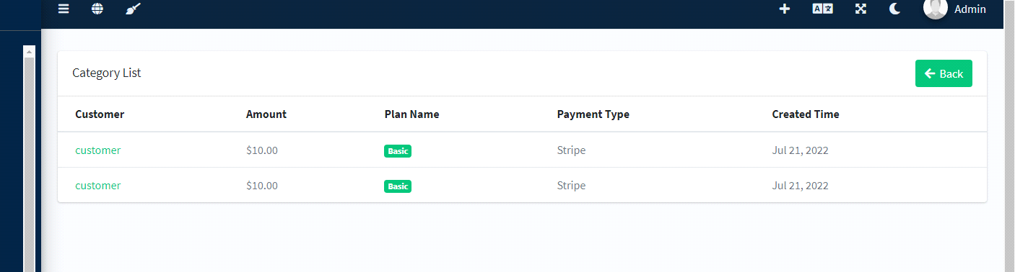
5. Customer wise payment history
6. Admin panel ar admin user list has error
7. Website->basic form is not updating
8. Social icon is not updating
9. Total package sell, total promote ads, total earnings

Frontend

1. Category count and ads list is not same
2. Ads details page a image show kore na
3. Forgot password on login page has no link
4. Terms and condition and privacy policy has no link on login page
5. User shop page default banner
6. User shop ads has no link
7. Purchase history of user dashboard 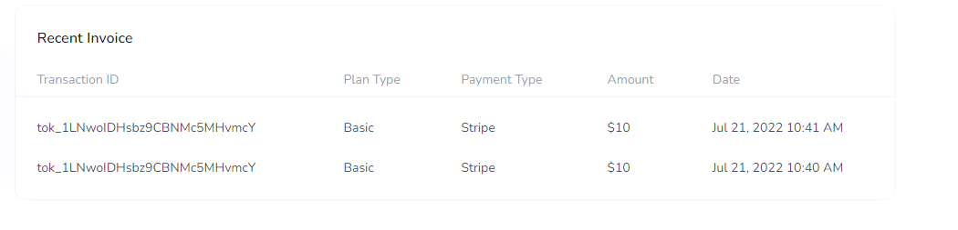
8. Bank transfer payment gateway
9. Transaction id missing